**Report explaining what updates has been done, why the updates have been done and how these changes would help in improving website design and user experiences. (Charity website example)**

**Following have been added**

Other Information

Donate

Get Involved

What we do

**Following have been removed**

**FUND RAISING**

**OUR WORK**

Linked items have been added into the top section of the front page because

* Relevant links added to aid navigation, classification and look of top part of page.
* It follows the ‘z notation’
* Proper categorised so that the users of website can easily go to the destination/desired page
* Tesler’s law has advised that “the design of the solution should take away the complexity” and by providing navigation and quick links to relevant things this purpose has been served.
* Resizing and removing extra spaces occupied by ‘our work’ and ‘fund raising’ sections a lot of space can be freed up on the page. Please note that the same information now available to user via links of options as above (under ‘what we do’ and ‘other information’). This is the way cluttered information has been grouped and provided the user with an organised and categorised look at the top of the page.
* This would make the page more desirable and useful and can aid users to navigate information without scrolling through a lot.
* This would follow principles of Information Architecture (IA) to make it more organised and easily navigable.

**Following have been added at the top-right**

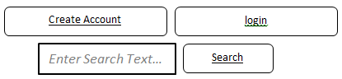

In the original wireframe there was an empty space at the top-right of the page. This space has been utilised by adding above three elements. ‘Create account’, ‘login’ and ‘search’ facilities;

Create account and login functionalities have been added at the top of the page to provide users with facilities to register and create accounts on the website. After registering/login they would be able to donate online in a secure and safe way to their chosen charity. This is an added facility in comparison to the original wireframe. The website search functionalities is moved into the unused space on top-right.

All these added functionalities would enhance usefulness, reliability, usability, creditability and subsequently visitors’ experiences of using this website. This would help in winning loyalty of users. This way user experience design improvement is achieved in updated wireframe of the page.

**‘Upcoming events’ parts have been moved in the middle of the page and combined with added search facilities as under:**

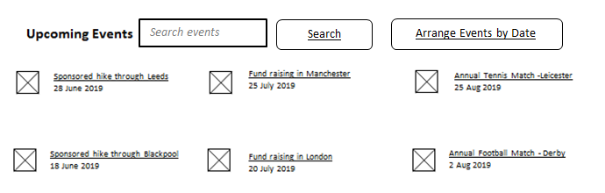

As per Miller’s Law “7 plus or minus 2 bits of information; this is the way in which the human mind best remembers information”. Therefore, at maximum 6 upcoming events (and links to navigate to them) would be displayed on the first page.

If the user wants to find out and search some events which are not listed in the group they would have facilities to search for events using 'search events' facilities and they would be able to arrange the events by date clicking on 'Arrange Events by Date.

The search facilities would help users to find out about upcoming events (which may not be listed on front page) quite easily and well in advance. This would help in planning out and attend those events which may result in having higher attendance and consequently more donations during those events.

The main aim behind this change is to increase usefulness and value of the information provided via ‘events section’ on the page.

**Following part has been removed**

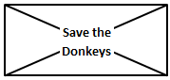

**Promoted Charities**

Instead introduced with which will display promoted charity of the month and related news as under.

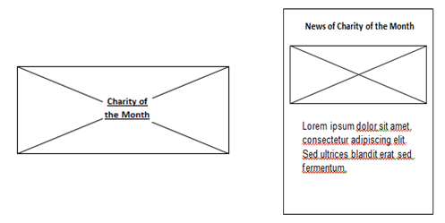

Main aim behind this update is to relate and group related information and present the website content in a way that this would follow the positives of Information Architecture (AI).

By grouping as above the information which is being presented (that is related with selected charity) has become more organised, clearly labelled and searchable within the page.

**Following ‘news items’ have been moved from the middle of the page to bottom:**

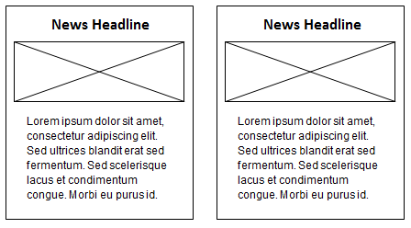

and organised as under at the bottom of the page.

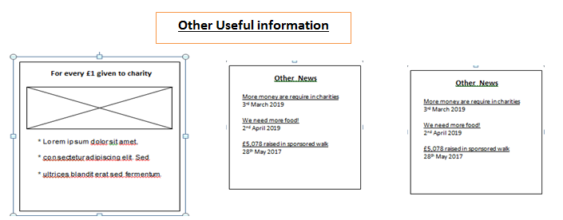

In the same section the users will get more information (apart from current charity related news) about how the donation money is being utilised/spend by the company. This extra information would increase credibility and users confidence into the brand and image of the company.

The news items are also grouped and moved along to make relevant information more organised and clear to the users. It seems more logical to have ‘promoted charity information and news’ above the ‘other news items’ on the page.

**Lessons learnt/challenges overcome**

* End-users experiences while using the website or application can determine ultimate success and failure of the delivered product.
* With the help of user experience design one can improve the user experiences by taking consideration of usability, usefulness, desirability, creditability, accessibility and value.
* As a developer I can utilise use case diagram (which shows high level functionalities) along with user stories to understand users' perspectives. Interaction design can also be utilised to make website engaging and meaningful from users' perspective.
* Images, words, hardware of users and processing time are important elements of Interaction design.
* Information presented on website should be well organised, navigable, clearly labelled and searchable to aid user experiences. Wireframe can help designing format and functionalities of website.
* A webpage's structure and content can be expressed with the help of various elements of Hyper Text Mark-up Language (HTML) and Cascading Style Sheets (CSS) can be used to style HTML elements.
* CSS rules may be applied to an element in following four different ways; default, inline, external and internal. CSS grid model may be used to aid responsive design of the webpage. Media queries can be used to make webpage responsive to various browser sizes.
* In the project I have utilised CSS box model to over challenges of positioning various elements of wireframe.
* The challenges of responsive web design (so that the developed project/website can become responsive to different display/viewports sizes) have been overcome utilising the concepts of media queries in CSS styling rules.
* The main aim was to analyse initially given wireframe and improve it. I have improved the given wireframe with the help of user interaction design, the principles and then grouped and presented the various elements of wireframe in user-friendly way by considering user experience designing fundamentals.

**Summary**

After all of the above changes the updated wireframe can be divided into following sections:

Top part of page which contains very important functionalities (create/login account and search) and links to various pages explaining (What we do, how the users can get involved, online donation and other useful information).

The middle of the page contains information about upcoming events (in a better organised & searchable) and promoted charities information.

The bottom half of the page provides information related with how the money being donated is spent by the company on various charities and other charity related important news.

Main goals behind these updates are to make this website more engaging and user interactions with the website more meaningful. These updates would help in improving usability, desirability, value and creditability of the website. All of these would result in having more number of users using the website and would create a base of loyal users who would be able to find out required information without any difficulties from the website and donating to desired charities in few clicks.

**Note**: Please see the second page in file containing updated wireframe to find out why a minor change has been done in initially submitted wireframe.